**Midterm “programming fundamentals**

**Q/ Advantages of user-defined functions.**

1. Abstraction: User-defined functions help to decompose a large program into small segments which makes program easy to understand, maintain and debug.

2. Reusability: If repeated code occurs in a program. Function can be used to include those codes and execute when needed by calling that function.

3. Organizing: Programmers working on large project can divide the workload by making different functions.

**Q/ Advantages of using Recursive Function:**

1. Complicated function can be split down into smaller sub-problems.

2. Sequence creation is simpler through recursion than utilizing any nested iteration.

3. Function code looks simple and effective.

**Q/ Disadvantages of using Recursive Function:**

1. a lot of memory and time is taken through recursive calls.

2. Recursive functions are challenging to debug

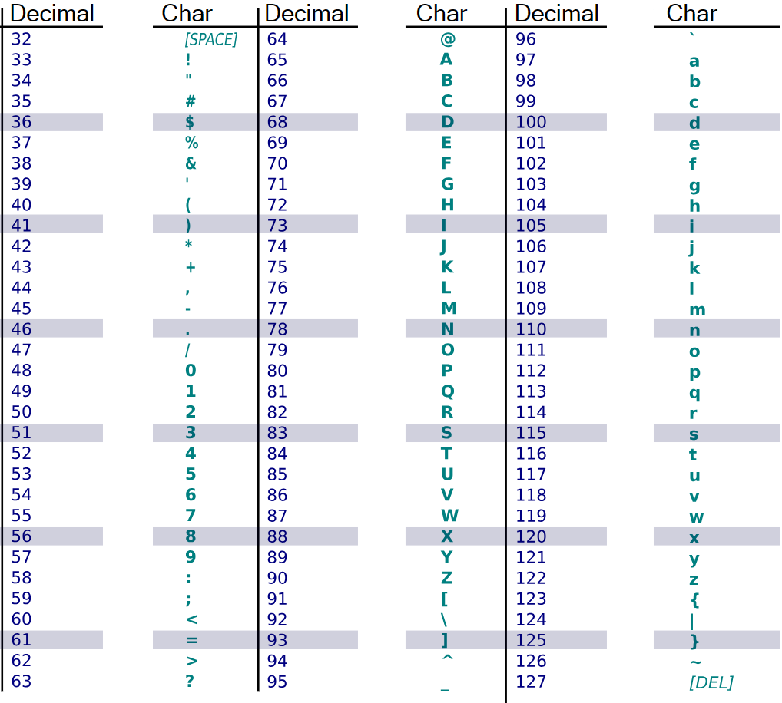**ASCII/UNICODE**

Not*

* If you want to know a specific character's ASCII/UNICODE code point value, you can use a function named ord().
* If you know the code point (number) and want to get the corresponding character, you can use a function named chr().

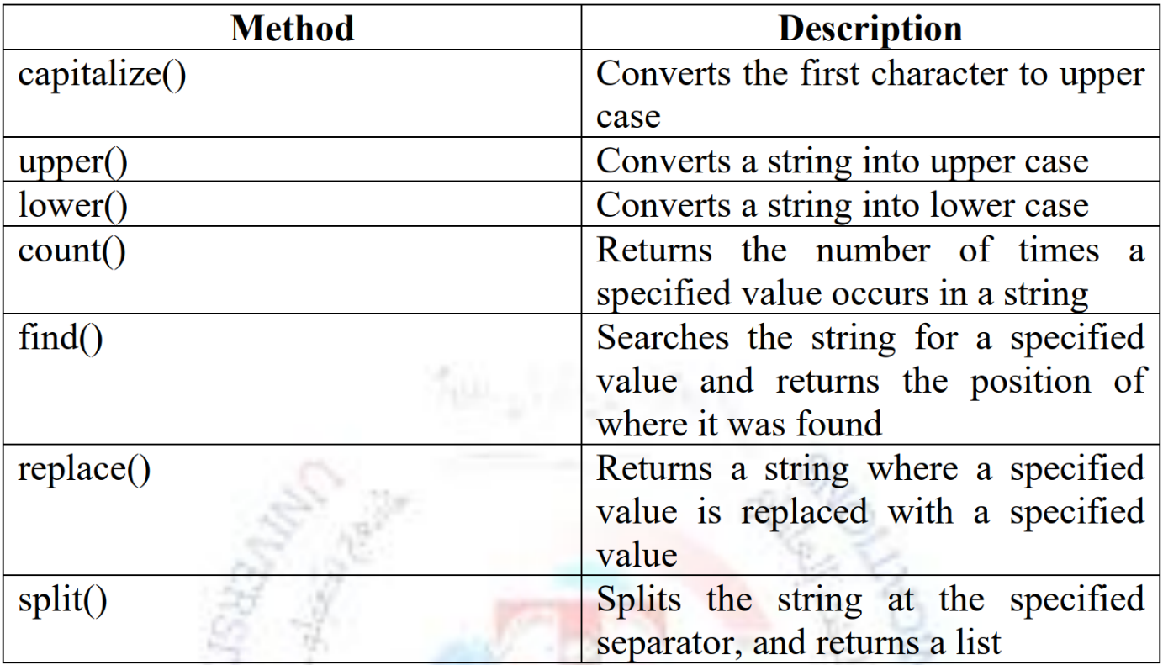**Method of string:**

**Method of list:** 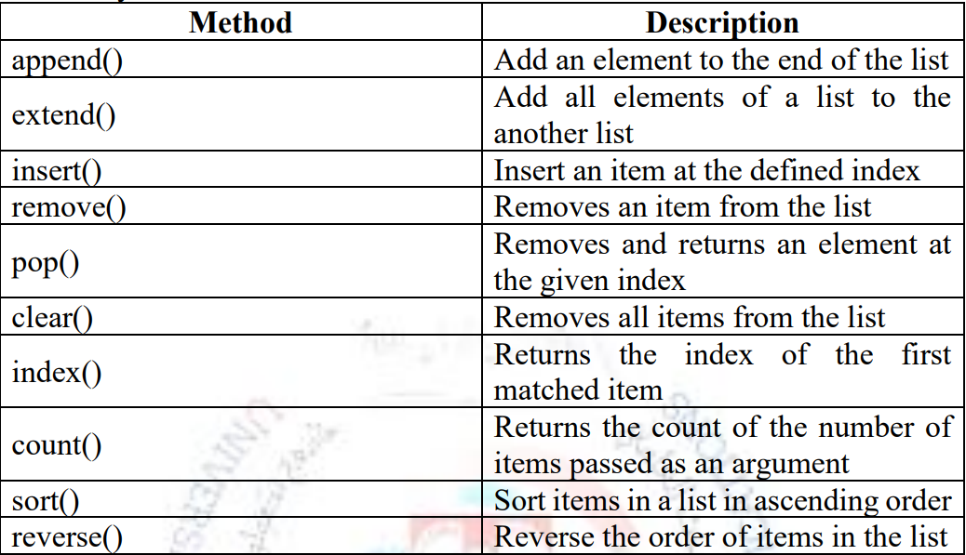

**Method of Tuple:**

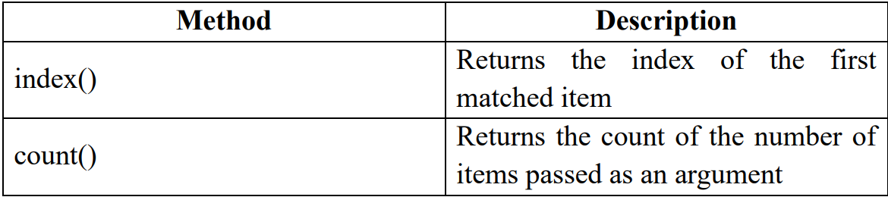

**The different between**

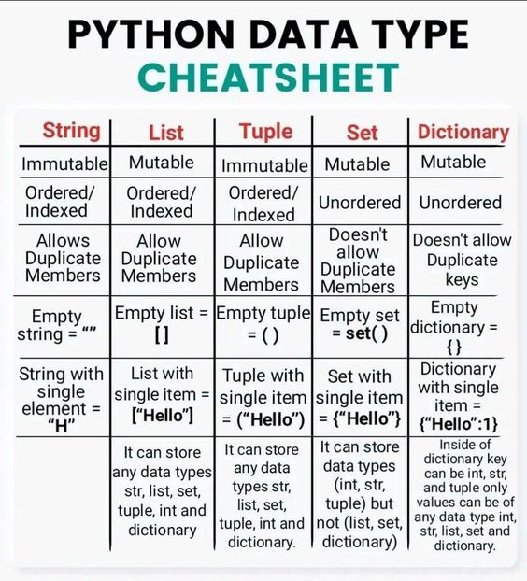**(String, list, Tuple, set, dictionary**

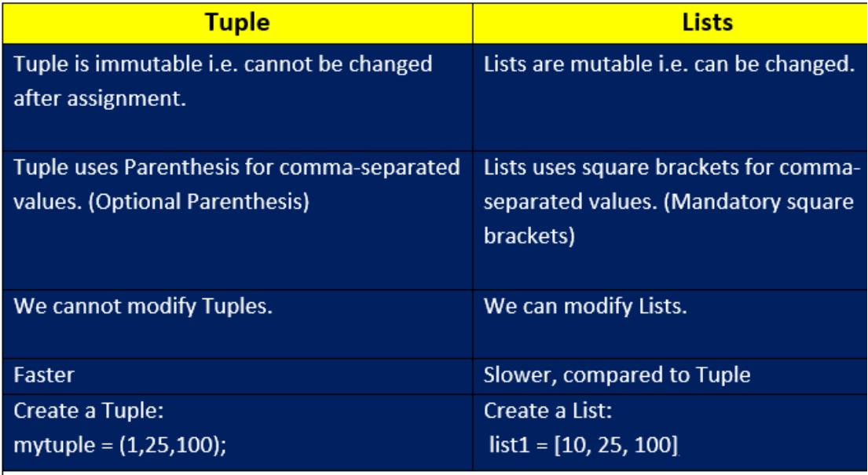**The different between Tuple and list:**

**Operations and Functions on Set**

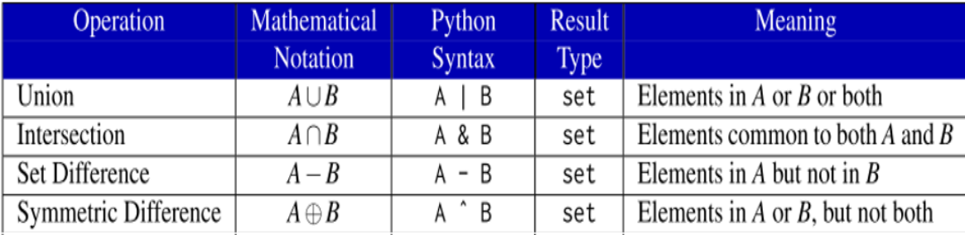

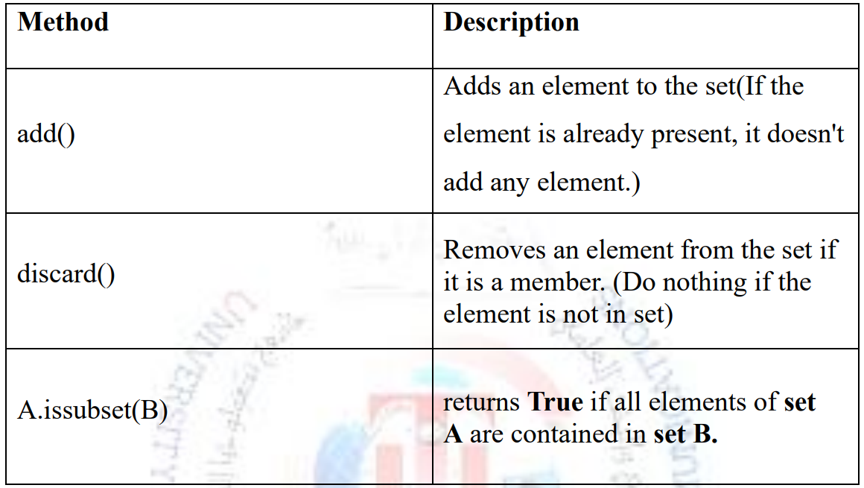**Method of set:**

**Method of dictionary:**

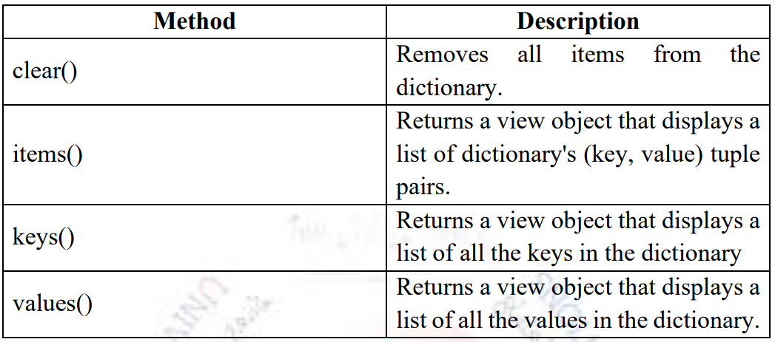

**Opening Files in Python:**

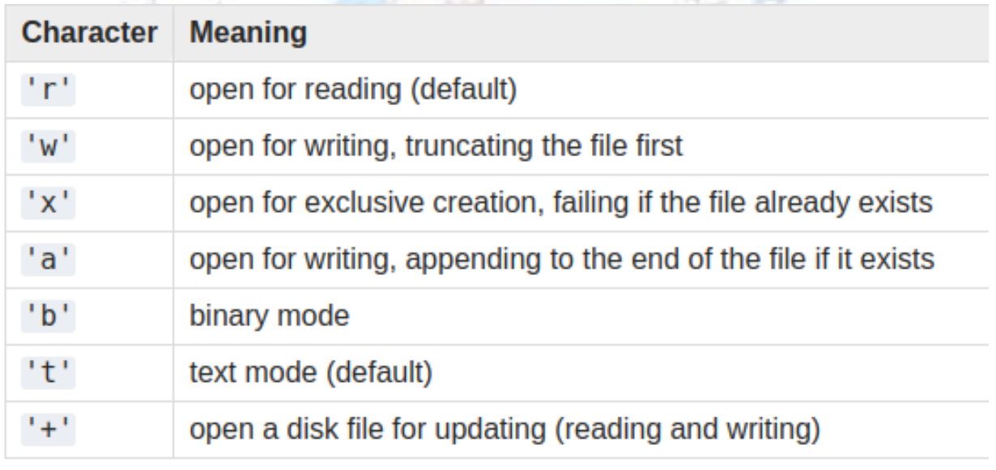

**The different between Normal function and lambda function:**

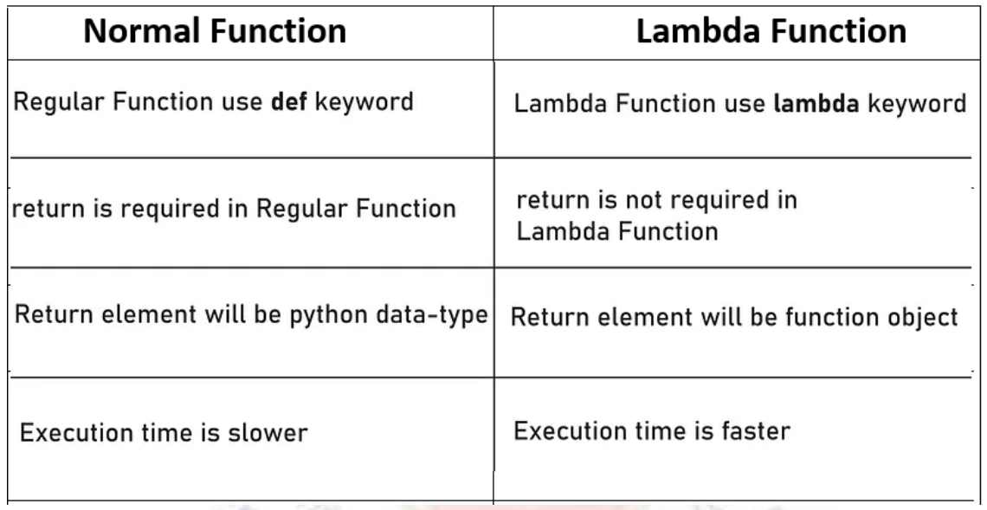

**Syntax of Python Lambda**

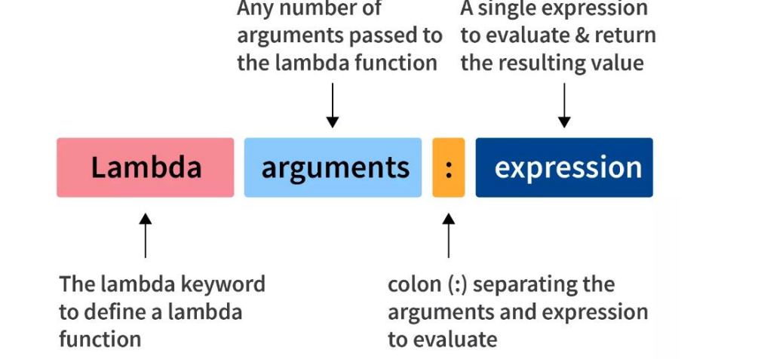

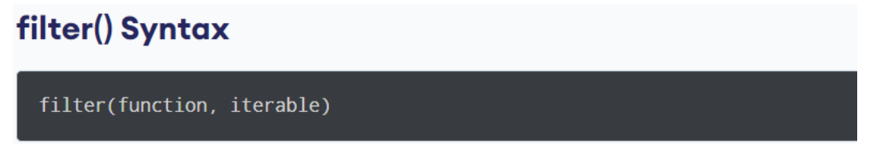

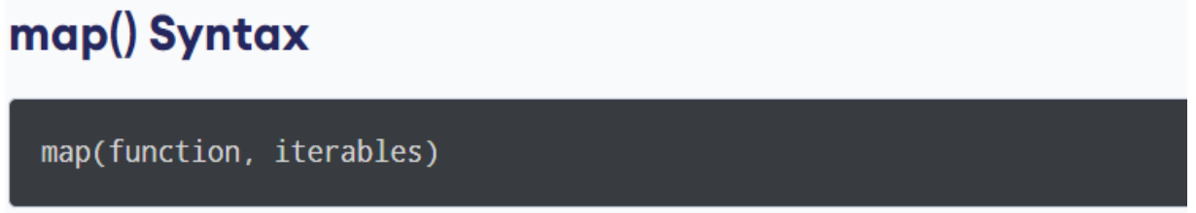

**Python Variable Scope:**

In Python, we can declare variables in three different scopes. We can classify Python variables into three types:

1. Local Variables

2. Global Variables

3. The global Keyword

**Local Variable Vs. Global Variables**

